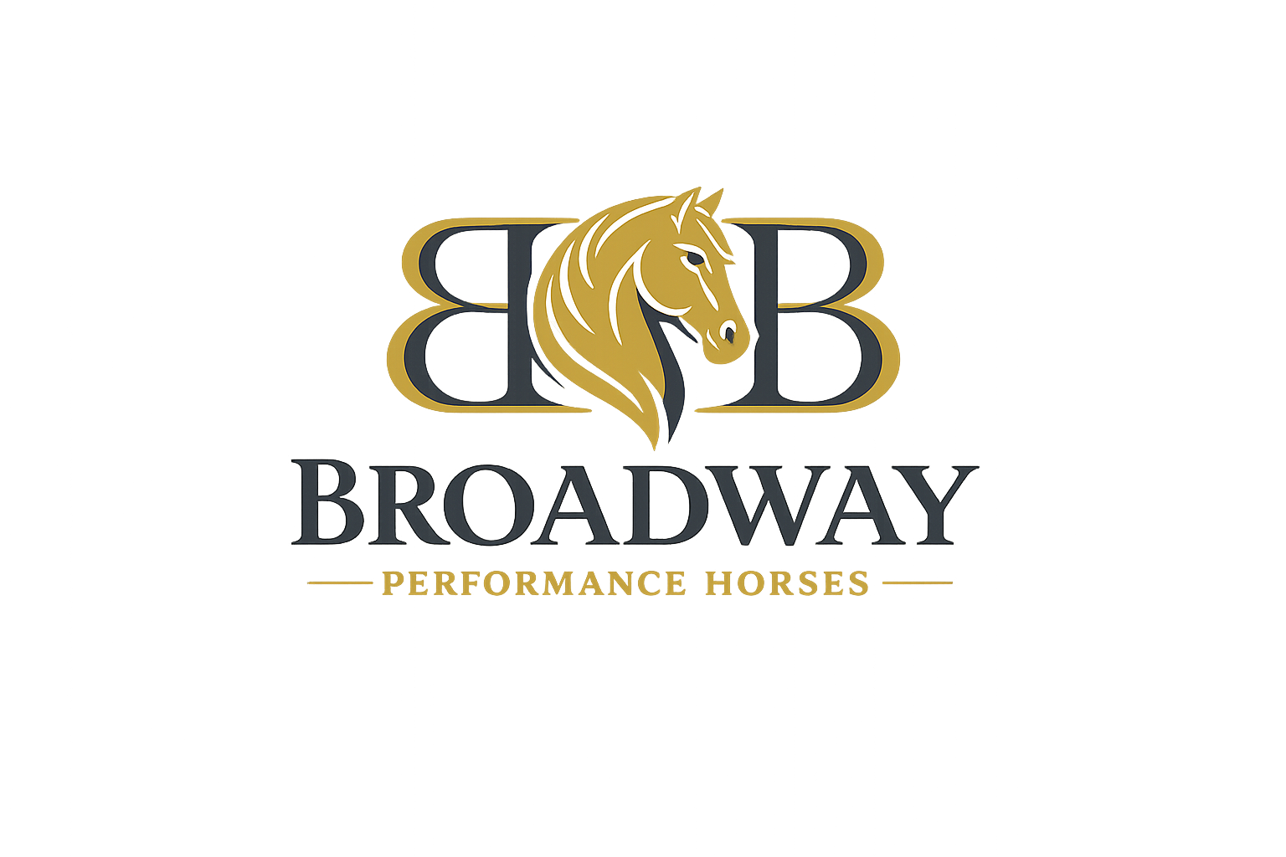
HORSE RIDING AND HANDLING
RISK ACKNOWLEDGEMENT, RELEASE AND PROPERTY AGREEMENT
Broadway Performance Horses
Property: ____________________________________________________________
Property owner / occupier: ____________________________________________________________
Participant's full name: ____________________________________________________________
Date of birth: ____________________________
Address: ____________________________________________________________
Phone: ____________________________
Emergency contact: ____________________________________________________________
Emergency contact phone: ____________________________

Important Warning
Horses are large, powerful and unpredictable animals. Horse riding, groundwork, feeding, grooming, leading, catching, loading, transporting, paddock work and other horse-related activities involve inherent risks of serious injury, permanent disability and death.
A horse may react suddenly and without warning. It may bite, kick, strike, crush, pull away, bolt, rear, buck, trip, fall or collide with a person, animal, fence, vehicle, building or other object.

Participant Acknowledgement
- I enter the property and participate in horse-related activities voluntarily and at my own risk.
- No representation or guarantee has been made that any horse, activity, equipment or area of the property is completely safe.
- I am responsible for honestly disclosing my riding and horse-handling experience, physical limitations, medical conditions, allergies, medications or other matters that may affect my safety.
- I will not ride, handle, feed, move, train, catch, release or enter an enclosure containing a horse without permission from the property owner or a person authorised by the property owner.
- I will follow all instructions, safety rules, signs and directions immediately.
- I will wear an approved, correctly fitted and fastened equestrian riding helmet whenever mounted and whenever directed to do so.
- I will wear suitable riding footwear with a defined heel and appropriate clothing.
- I understand that an equestrian body protector or safety vest is strongly recommended, particularly for children and inexperienced riders.
- I will not participate while affected by alcohol, illegal drugs, impairing medication, illness, fatigue or any condition that may make participation unsafe.
- I will immediately report damaged equipment, unsafe fencing, injuries, loose horses or other hazards.
- I will not mistreat, frighten, chase, strike, overwork or deliberately place any horse at risk.
- The property owner may stop me from riding or handling a horse at any time if my conduct, experience, equipment, health or behaviour presents a risk to me, another person, the property or a horse.

Assumption of Risk
I knowingly accept the ordinary and inherent risks associated with horses and rural property, including risks arising from:
- unpredictable horse behaviour;
- falls, bites, kicks, trampling, crushing or being pulled or struck;
- uneven, wet, muddy, slippery or damaged ground;
- fences, gates, yards, stables, sheds, machinery and vehicles;
- trees, branches, holes, rocks, wildlife, dogs and other animals;
- weather, fire, dust, insects and changing property conditions;
- equipment failure or incorrect use of equipment;
- the actions of other riders, handlers, visitors or animals; and
- my own actions, judgment, experience or failure to follow instructions.

Release and Limitation of Liability
To the maximum extent permitted by law, I release and discharge the property owner or occupier, the horse owner, and their family members, employees, contractors, volunteers and authorised representatives from claims arising from my voluntary participation in horse-related activities or presence in horse areas.
This release is intended to apply to personal injury, death, property loss or property damage arising from the inherent and obvious risks of horses and rural activities. Nothing in this agreement excludes or restricts any liability or legal duty that cannot lawfully be excluded.

Responsibility for Horses and Property
I agree that I am responsible for any loss, injury or damage that I intentionally cause, or that results from my reckless conduct, unauthorised actions or failure to follow instructions.
I will not:
- remove a horse from the property without written permission;
- allow another person to ride or handle a horse without permission;
- use another person's saddle, bridle, equipment, vehicle or machinery without permission;
- administer medication, supplements or treatment to a horse without permission;
- change a horse's feed, paddock or routine without permission;
- sell, lease, advertise, post as available, or represent any horse as belonging to me; or
- permit another person to enter horse paddocks, yards or restricted areas without permission.
I agree to pay the reasonable cost of repairing or replacing property or equipment damaged through my deliberate, reckless or unauthorised conduct.

Personal Insurance
I understand that the property owner's insurance may not cover me. I am responsible for arranging my own ambulance cover, health insurance, personal accident insurance and equestrian insurance where appropriate.

Emergency Assistance
If I am injured or become unwell and cannot provide instructions, I authorise the property owner or another person present to contact emergency services and arrange reasonable first aid or medical assistance. I understand that I am responsible for ambulance, medical and associated expenses incurred on my behalf.

Photographs and Incident Records
I consent to photographs or video being taken where reasonably required to document an incident, injury, property damage, horse welfare concern or breach of this agreement.

Continuing Agreement
This agreement applies each time I enter the property or participate in horse-related activities unless it is replaced or withdrawn in writing.

Declaration
- I have read and understood this agreement;
- I have had the opportunity to ask questions;
- I understand that serious injury or death may occur;
- I have disclosed my experience and relevant medical information honestly;
- I am signing voluntarily; and
- I agree to comply with all property and horse-handling rules.
Participant's name: ____________________________________________________________
Participant's signature: ____________________________________________________________
Date: ____________________________
Witness's name: ____________________________________________________________
Witness's signature: ____________________________________________________________
Date: ____________________________

Parent or Legal Guardian Consent
Required when the participant is under 18.
I am the participant's parent or legal guardian. I consent to the participant entering the property and participating in the activities described in this agreement. I confirm that I have explained the risks and rules to the participant in language appropriate to their age and understanding.
Parent / guardian name: ____________________________________________________________
Relationship to participant: ___________________________________
Phone: ____________________________
Signature: ____________________________________________________________
Date: ____________________________

Participant's Horse Experience
Experience level: Beginner / Intermediate / Experienced
Previous riding or handling experience: ____________________________________________________________
_______________________________________________________________________________________________
_______________________________________________________________________________________________
Relevant medical conditions, allergies, injuries or medications: ____________________________________________________________
_______________________________________________________________________________________________
_______________________________________________________________________________________________
Horse authorised to be ridden or handled: ____________________________________________________________
Permitted activity: ____________________________________________________________
Restrictions or special instructions: ____________________________________________________________
_______________________________________________________________________________________________
Authorised by: ____________________________________________________________
Date: ____________________________

